LAB :2

Exercise 1

Given 3 int values, a b c, return their sum. However, if any of the values is a teen -- in the range 13..19 inclusive -- then that value counts as 0.

**Sample Run:**

**Input:** a=3, b=1, c=4 ; a=21, b=1, c=2 ; a=13, b=1, c=19

**Output: Sum= 8, ; Sum=24 ; Sum = 1**

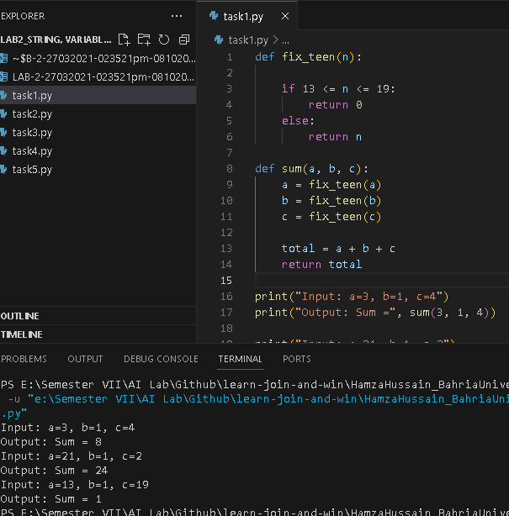

Exercise 2

Given a string input Count all lower case, upper case, digits, and special symbols.

**Sample Run:**

**String:** ABC123@gmail.com

**Output: lowercase = 8, uppercase = 3 , special symbols = 2 , digits = 3**

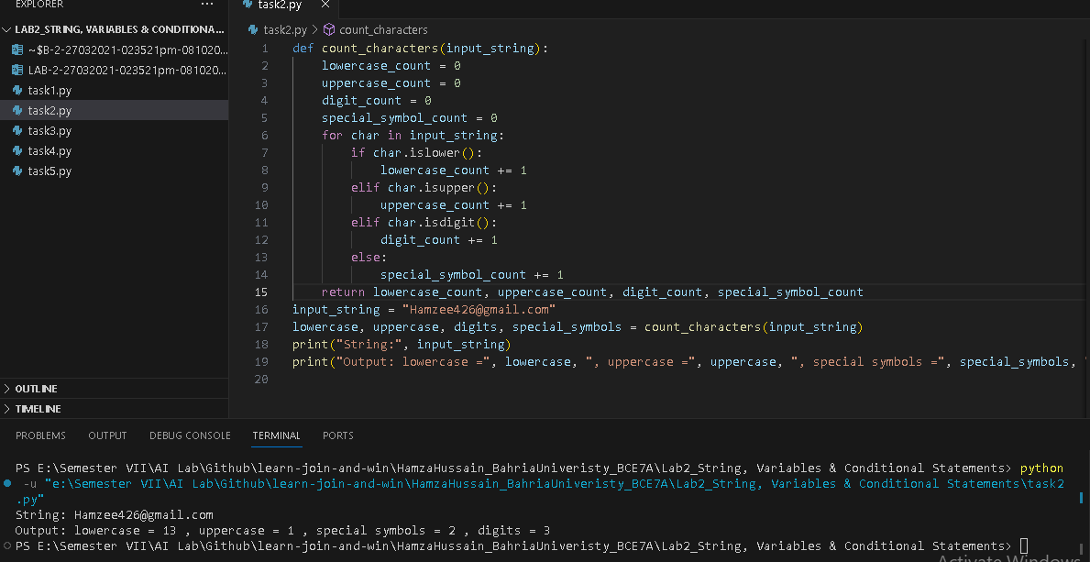

Exercise 3

Given a string, return the sum and average of the digits that appear in the string, ignoring all other characters.

**Sample Run:**

**String:** Q-301 is at 4 th floor of quaid block.

**Output: Sum = 8 and Average is 2**

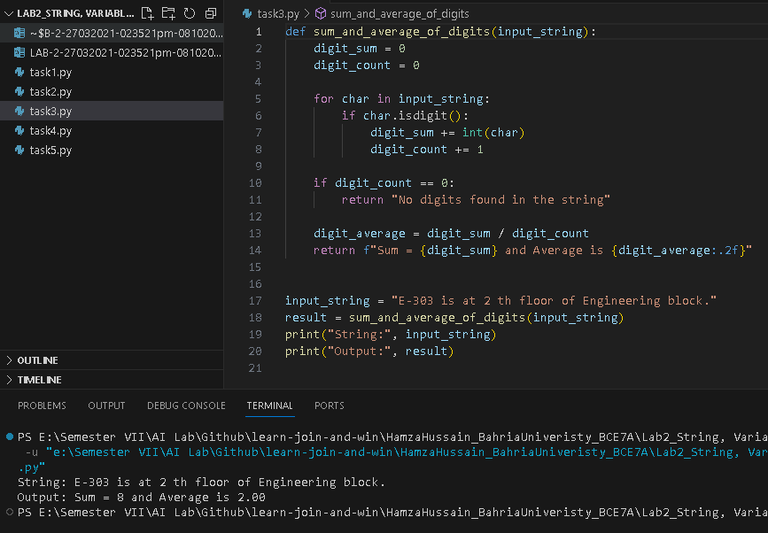

Exercise 4

Given an array length 1 or more of ints, return the difference between the largest and smallest values in the array. Note: the built-in min(v1, v2) and max(v1, v2) functions return the smaller or larger of two values.

**Sample Run:** 1,2,3,4,5,8,9,10,15,40,3

**Input: min = 1, max= 40 difference = 39**

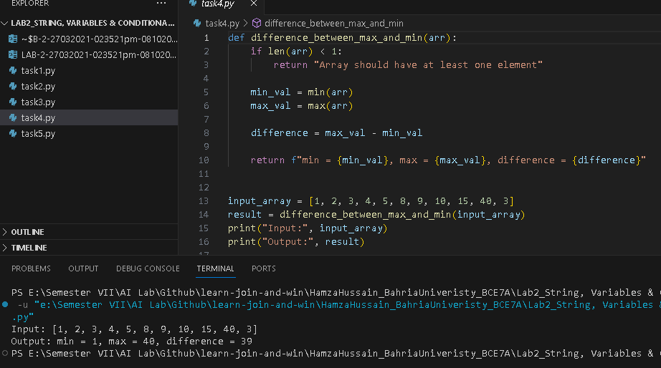

Exercise 5

Return the number of times that the string "ant" appears anywhere in the given string, except we'll accept any letter for the 'n', so "art" and "abt" and other counts.

**Sample Run:**

**String:** Antandart

**Output: count = 2**

